TeamGym Newcastle Open
Competition Information Pack
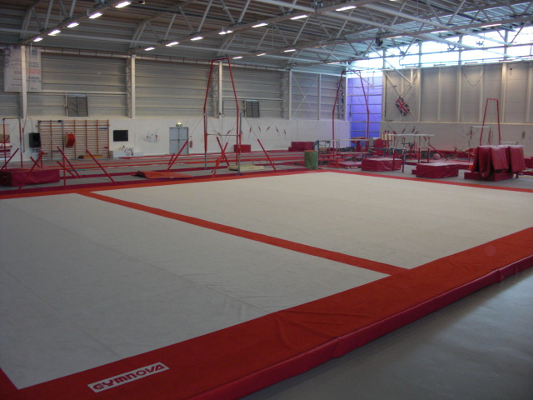Our new full size Team Gym Floor Area
16th June 2013 Full size TeamGym floor Area
1. The Venue
City of Newcastle Gymnastics Academy
Benfield Centre Sports Centre
Benfield Road
Newcastle Upon Tyne
NE6 4NU
Telephone 0191 275 9009
Email: contact@newcastlegymnastics.org

2. Entry Forms
Cost of entry for 2013 will be £135 per team.
Entries must be made on the entry form and submitted to:
Karen Chapman, 63 Farringdon Road, Cullercoats, North Shields, Tyne & Wear NE30 3EX
Please ensure cheques are made payable to ‘C.N.G.A.’.
If you wish to email your entry - Karen@newcastlegymnastics.org
Please make payment by Debit Card over the phone.
The closing date for receiving applications is 12 noon on Friday 17th May 2013
Please note that any late entries will be at the discretion of the competition organisers.

3. Podium training
Podium training is available at an extra cost of £20 per team and will be made available on the evening of Saturday 15th June 13, by pre-arrangement with the competition organisers, for those teams that wish to orientate to the apparatus.
Depending on demand, time slots will be allocated between 4.00pm and 8.00pm on a first come, first served basis, and may be limited to touch warm-up times only.
Please contact the organisers at karen@newcastlegymnastics.org as soon as possible to discuss requirements. Please note the organisers cannot guarantee allocation of your preferred time slot.

4. Music
Music is to be submitted at the event, coaches are advised to bring 2 copies of each music CD to the event.

5. Judges, Coaches and Gymnast Passes
Passes will be distributed at registration and will be for each named Judge, Coach and gymnasts. Only two coaches per club will be allowed into the competition arena, plus a chaperone if required.
All teams must dedicate a judge otherwise a fine of £25 will occur.
6. Spectator Tickets
Spectators at this event will be in the spectator seating area in the gym hall. Tickets will be £7 for an all-day pass (U14 £3.50). Depending on team entries the morning session is the Primary competition and the afternoon session is the Junior and Senior combined. There are 300 seats for the competition.
Spectators are advised to order tickets early to avoid disappointment, to pre-order tickets please complete the application form and return it with payment, payable to C.N.G.A. to Mrs K Chapman, 63 Farringdon Road, Cullercoats, North Shields, NE30 3EX
Tickets will not be issued in advance of the event but instead can be collected at the spectator entrance to the competition

7. Photography
British Gymnastics Photography Regulations will be followed for this competition.

8. Tariff Sheets
Current tariff forms that are appropriate for Level 1 can be obtained from the British Gymnastics, TeamGym North or TeamGym UK web site.
www.british-gymnastics.org - www.teamgymnorth.co.uk - www.teamgymuk.com
Level 2 and 3 should use the same tariff sheets and judges will make suitable allowance for the compositional requirements.
Completed tariff sheets must be handed in at the time of Registration. Amended tariff forms cannot be accepted after that time.

9. Jewellery
Please note that the policy of jewellery for gymnasts AND coaches is zero tolerance. No jewellery whatsoever is allowed in the performing areas. Should a judge see jewellery during a performance, they will stop the routine as soon as it is safe to do so. When removed, the team will be allowed to continue, but they will receive a penalty.

10. Coach Qualifications
Please note that BGA have clarified that it is the clubs responsibility to ensure that they provide coaches suitably qualified to the level and appropriate standard of the competing gymnasts. You are reminded that the rules of the event demand that TWO coaches must be present on the landing area for Trampette before the Head Judge in that discipline may signal the start of that event.

11. Apparatus Clarifications
Please be advised that the floor area for the competition will be Artistic size.
There will be two run-ups provided for Trampette.
Clubs are advised that the competition organiser will provide 2 Eurogym Trampette or 1 Continental for the use of any team that prefers not to bring their own. It is the Coach’s responsibility to ensure the equipment is appropriately placed and safe to use.
Vault Height - The height of the vault will be as new code.
It is the responsibility of the coaches to ensure that the vault is adjusted prior to their team’s training or competition slot.

12. Trophies
It has been agreed at previous tournaments, that trophies would be presented to the winners of each section.
Would the recipients of the 2010 Ken Sunderland Memorial Trophy please ensure that it is returned to the organisers before or on the day of the competition.

13. British Gymnastics Age and Competition Policy
The age range for the National Primary teams in the 2013 will be 9 to 12 in the year of competition.
The age range for the Regional Primary teams remains the same at 8 to 12 in the year of competition

We are looking forward to a great day of gymnastics; hope you can join us….

