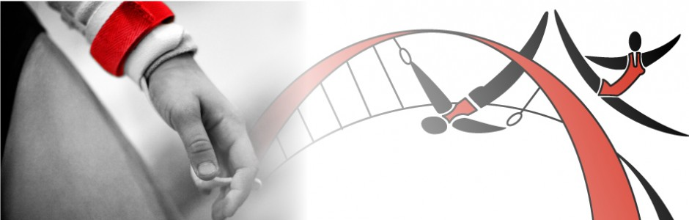

TEAMGYM NEWSLETTER
This month we are all preparing for upcoming displays. For this it takes time and effort from all coaches and gymnasts, but we do need more concentration on attendance and commitment within the gym. There are a lot of gymnasts whose attendance is still poor, and this becomes difficult when trying to work out routines and tumble & trampette runs.
Your gymnast will have received a little card with their current attendance score this will be reviewed in November and any percentages that are still below 80% may lose their place in that team.
Upcoming Events
Displays
- Teamgym Display Night
Sunday 10th November
- Christmas Displays 20/21/22 December
Competitions

- 2nd February (provisional) Scottish open
- 1st March British Qualifiers
- 24th May British Championships
- 15th June Newcastle Open

Coaches Contact Details

Sam Smith- samsmith2809@yahoo.co.uk

Ruth Tonks – ruth.tonks@hotmail.co.uk

Hannah Rowley- Hannahgr92@hotmail.co.uk

Lesley Rutter- lesleyrutter@live.co.uk

Entry Fees
Entry fees for both Scottish open and British Qualifiers will be due 12th December
Scottish open - £ 10 (approx.)
British Qualifiers –£ 12 (approx.)
GYMNAST OF ThE MoNTH
- Primary Regional -Chanelle Burwood- excellent trampette work
- Primary National- Ellie Jones – Working really hard and good progress
- Junior Regional – Annabel Weir – Achieving great new skills and showing excellent improvement
- Junior National – Hannah Peggie- Achieving Great news skills and an excellent attitude towards gym

Work Hard and maybe next time it will be you!!

80% and Above!!
As mentioned in the last article if gymnast attendance is poor they may lose their place in the team. So I have decided that if your child attendance drops below 80% there place may be lost in that team, unless due to unforeseen circumstances then this can be discussed with Sam.
Gymnasts will receive attendance cards every 2 months to see their current percentage.
Well done to all the girls with 80% and above Great Commitment well done

Conditioning Challenge
- 15 squat jumps in 10 Seconds
- 30 star jumps holding 2 cans of beans
- Press ups during the X factor ad breaks. NO stopping.

